TC-DISP-034
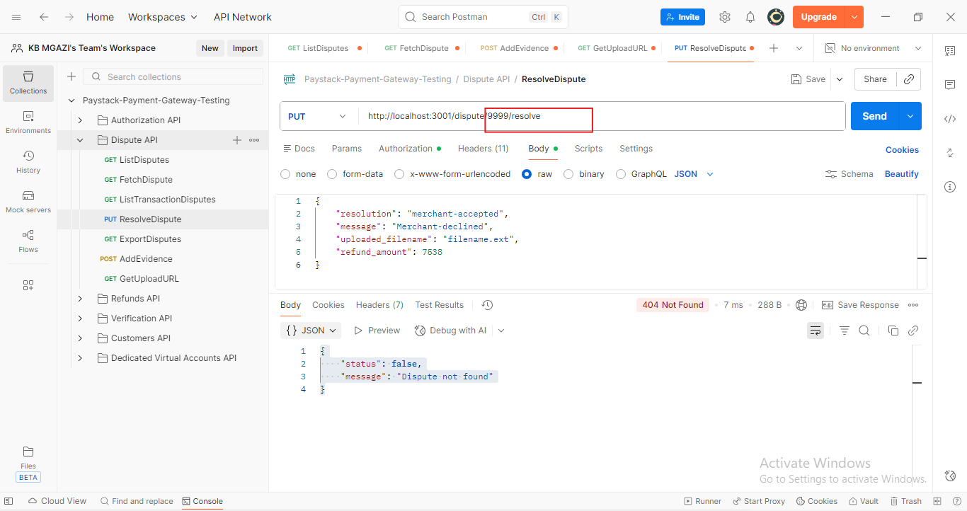
Request:
{
"resolution": "merchant-accepted",
"message": "Merchant-declined",
"uploaded_filename": "filename.ext",
"refund_amount": 7538
}

Response:
{
"status": false,
"message": "Dispute not found"
}

